α

The Alpha Software Development Team

User Manual

Prepared for: Sergeant Patrice Poitevin

Prepared By:

Hussain Farbotko-Merabaksh, Project Leader,

Nicolas Castilloux,

Curtis Collins,

Anthony Guevara,

Patrick Ings,

Brian Reed

April 1, 2012

# Contents

Contents ii

Contact Information 1

Core 1

Project Team Leader: 1

Project Group Members 1

Project Professor And Project Advisor: 1

1 Human-Computer Interfaces 2

1.1 Entries 2

1.1.1 Main Entry Page 2

1.1.2 Create a new Entry 3

1.1.3 View Entries page 4

1.1.4 Edit Entries page 5

1.2 Zone 6

1.2.1 View Zone 6

1.3 Reports 7

1.3.1 View a Preset Report 7

1.3.2 Generate a Custom Report 7

1.3.3 Modify Report Parameters 7

1.4 Contributors 9

1.4.1 Main Contributors 9

1.4.2 Edit User 10

1.5 About 11

1.5.1 Main About Screen 11

1.6 Administration 12

1.6.1 Accessing the main page 12

1.6.2 View summary information 13

1.6.3 Adding a new Drug Detail 14

1.6.4 Editing a Drug Detail 15

1.6.5 View Drug Detail 16

1.6.6 Delete Drug Detail 16

1.7 Messages 17

1.7.1 View Inbox 17

1.7.2 View a Message 17

1.7.3 Reply to a message 18

# Contact Information

Sgt. Patrice Poitevin

Royal Canadian Mounted Police

Drugs and Organized Crime Awareness

Phone:(613) 296 9638

[Pat.poitevin@rcmp-grc.gc.ca](mailto:Pat.poitevin@rcmp-grc.gc.ca)

## Core

### Project Team Leader:

Hussain Farbotko Merabaksh

[hmerabaksh@gmail.com](mailto:hmerabaksh@gmail.com)

Project Leader

### Project Group Members

|  |  |
| --- | --- |
| Nicolas Castilloux  [nick.castilloux@gmail.com](mailto:nick.castilloux@gmail.com) | Curtis Collins  [wcurtiscollins@gmail.com](mailto:wcurtiscollins@gmail.com) |
| Anthony Guevara  [anthony.guev@gmail.com](mailto:anthony.guev@gmail.com) | Patrick Ings  [PatrickIngsJr@gmail.com](mailto:PatrickIngsJr@gmail.com) |
| Brian Reed  [brianreed23@gmail.com](mailto:brianreed23@gmail.com) |  |

### Project Professor And Project Advisor:

Mr. Edmund G. Strange

Algonquin College – Woodroffe Campus

Computer Studies Department

1385 Woodroffe Avenue

Ottawa, Ontario

K2G 1V8

Phone:(613)727-4723 ext 3483

strange@algonquincollege.com

# Introduction

The Drug Trend Mapping System (DTMS) was developed to help community partners identify trends in drug use in zones across the National Capital Region (NCR). Community partners input entries of drug usage events, and the DTMS generates reports based on these anecdotal entries to display broad trends in drug use to aid police and community partners in focusing awareness efforts.

## Features

The DTMS provides features to users and administrators of the system enabling ease of use, data integrity protection, and security. The DTMS has the following specific features:

## Intuitive Navigation

The DTMS allows users to navigate the system as a website with a standard interface that is easy to use, consistent and pleasing to look at. The primary navigation interface is the Navigation Bar displayed across the top of every page, as well as the breadcrumb provided on each page. It also allows users to view reports based on the data they are currently looking at from any Zone or Entry page.

## Data Integrity Protection

The DTMS is designed to ensure data is able to be correlated by having users enter data in dropdown menus. When a truly new datum needs to be entered, the user has the ability to fill in a “new” entry, with a warning to double check the entry does not already exist. The DTMS allows administrators to remove entries in the event that an error or duplication does occur.

## Security

The DTMS is designed to ensure that only approved community partners have access to the data. While no personally identifying information is stored in the system, the data is not intended to be released to the public. The system provides a mechanism for community partners who wish to contribute to request approval from the administrator.

## Requirements

In order to use the DTMS, you require a computer or other device capable of accessing the Internet on a modern browser, such as Internet Explorer 7 or higher, Firefox 3 or higher, or Google Chrome.

# Human-Computer Interfaces

## Entries

### Main Entry Page

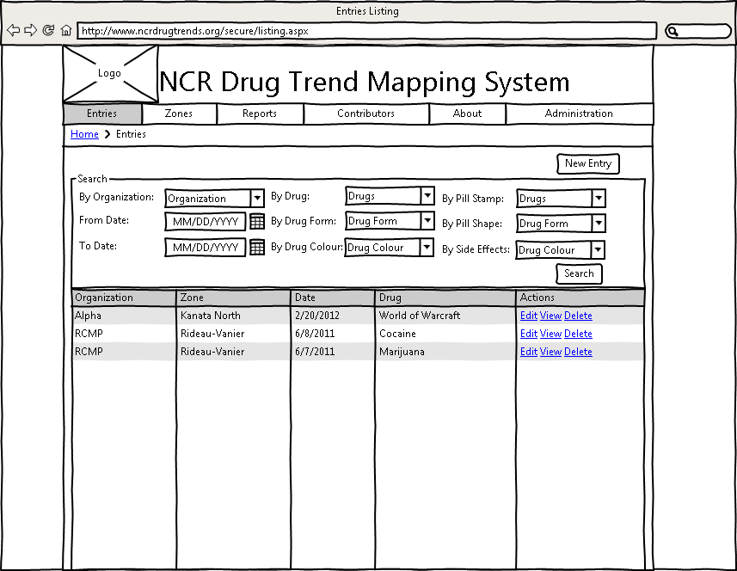

Figure 1: Entries Main Page

1. Log into the system.
2. Click the “Entries” link in the navigation bar to go to the Entries Page:
3. If desired, the user can search by organization name, to see the entries entered by that organization.
4. If desired, select start and end months and years to display only entries submitted between those dates.
5. If desired, the user can search by drug type, drug color, drug form, pill stamp, pill shape or side effect.
6. Click "view" to the right of any Entry for a detailed view of that Entry.
7. Click “edit” to the right of any Entry to edit that Entry.
8. Click “delete” to the right of any Entry to delete that Entry.

### Create a new Entry

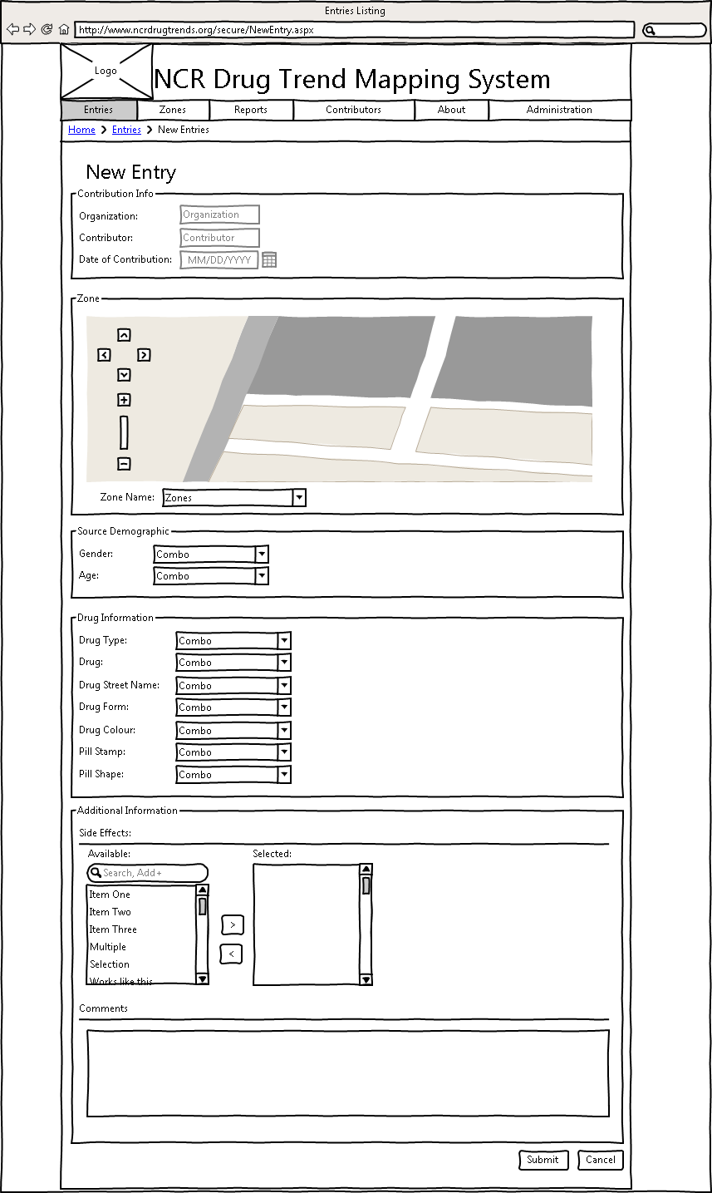

Figure 2: New Entry

1. Log into the system.
2. Click the “Entries” link in the navigation bar to go to the Entries Page:
3. Click the “New entry” link to go to the New Entry Page:
4. The Organization name and contributor is auto filled by your account details.
5. The Date of contribution is automatically filled in by the current date.
6. Select zones by either clicking on the map, or selecting them from the combo list.
7. Fill in any information about the Drug being submitted.
8. The user may enter side effects by selecting one and hitting the arrow to move it to the selection box.
9. The user may add Comments to the entry.

### View Entries page

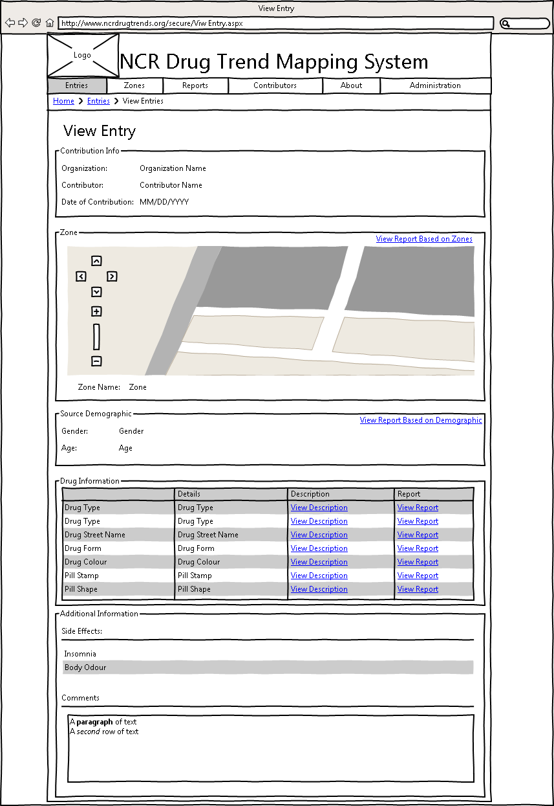

Figure 3: View Entry

1. Log into the system
2. Click the “Entries” link in the navigation bar to go to the Entries Page:
3. Click "view" to the right of any Entry for a detailed view of that Entry.

### Edit Entries page

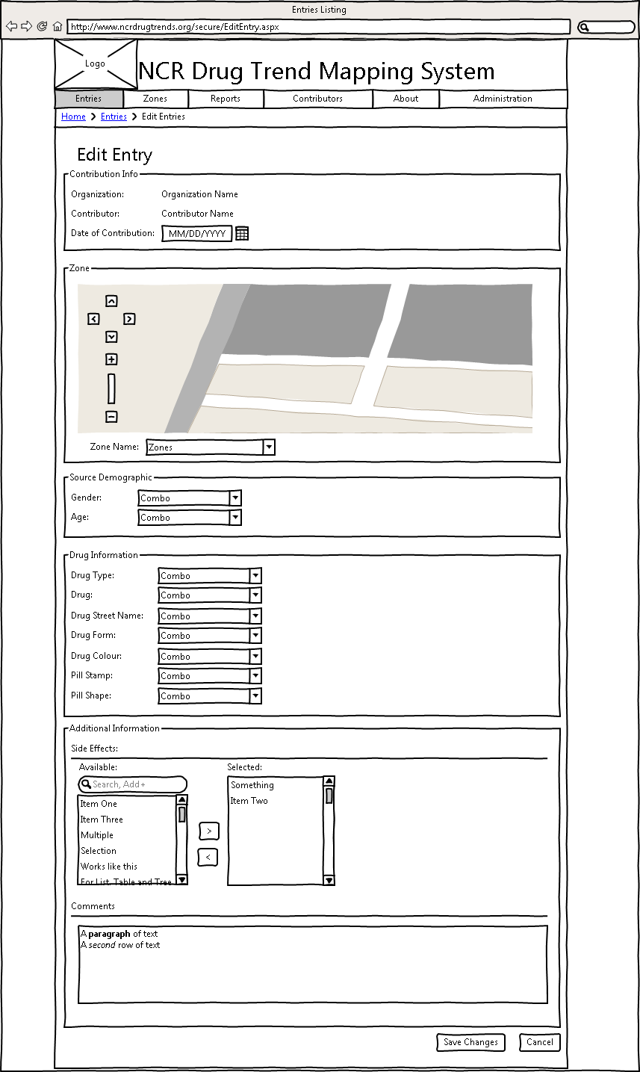

Figure 4: Edit Entry

1. Log into the system
2. Click the “Entries” link in the navigation bar to go to the Entries Page:
3. Click "edit" to the right of any Entry to edit that Entry.
4. The user may edit any field on the page, and/or add zones. The user cannot change Date of creation or organization name/contributor name.

## Zone

### View Zone

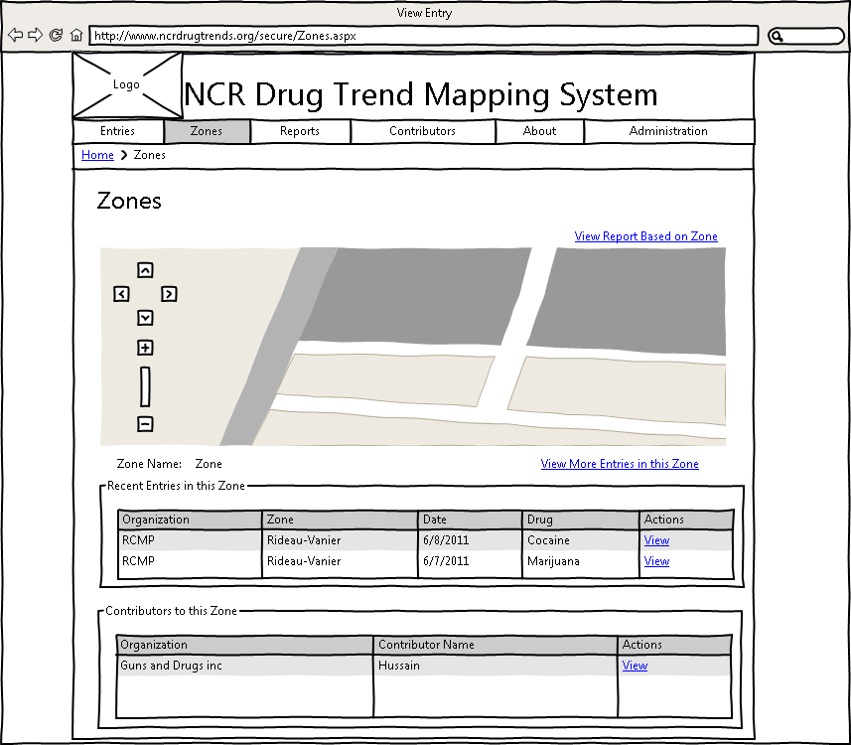

Figure 5: View Zone

1. Log into System. See Logging In)
2. Select the Zones tab located in the navigation bar below the page Title.
3. The page will display a Map provided by Google, centered on the city of Ottawa. The ward districts of Ottawa will be divided and colour coded on the map.
4. Hovering over the map, will allow the user to view the name of the zone the cursor is above.
5. Clicking on the Map will display detailed information pertaining to the Ward division in the two tables located directly below the Map. (See Zones Page) The Top Table will display a list of entries within the selected zone, specifically the information pertaining to their: Organization, Zone, Date, Drug and the option to view the contributor. The bottom Table will display a list of contributors in the selected zone, specifically the Organization, Contributor Name and the option to view each entry.
6. A new “View Report Based on Zone” link has been added to allow the user to view reports based on the selected zone.
7. A new “View More Entries in this Zone” Link has been added to allow users to view more entries not listed in the Recent Entries Table.

## Reports

### View a Preset Report

1. Log On to the System.
2. Click the “Reports” tab in the Navigation Bar to get to the Reports Page:
3. Select one of the Preset Reports from the dropdown list.
4. Click the "Generate Preset Report" link under the dropdown.
5. The report will be created and displayed under the report parameters area.

### Generate a Custom Report

1. Log On to the System and go to the Reports Page (see section 2.3.1).
2. Click one of the Chart Type images located in the custom report section to select that Chart.

Note: The Heat Map is always displayed as a Print-Friendly Version. See 2.3.4.

1. Select the Field to compare by.
2. Select which items in that Field to include, or click "Select All" to check all the boxes (and uncheck any you wish not to include.)
3. If desired, constraints can be selected for specific filtering. All of the advanced filters default to include all possible information.
4. Select the start and end dates for the data to be compiled in the report from the appropriate dropdowns.
5. Click “Generate Report.” The report will be created and displayed under the report parameters area.

### Modify Report Parameters

1. Log on to the system and generate a report (see section 2.10).
2. The report parameters area will still be present over the generated report. Change any of the report parameters desired and click “Generate Report” again to view the report with the modified parameters.

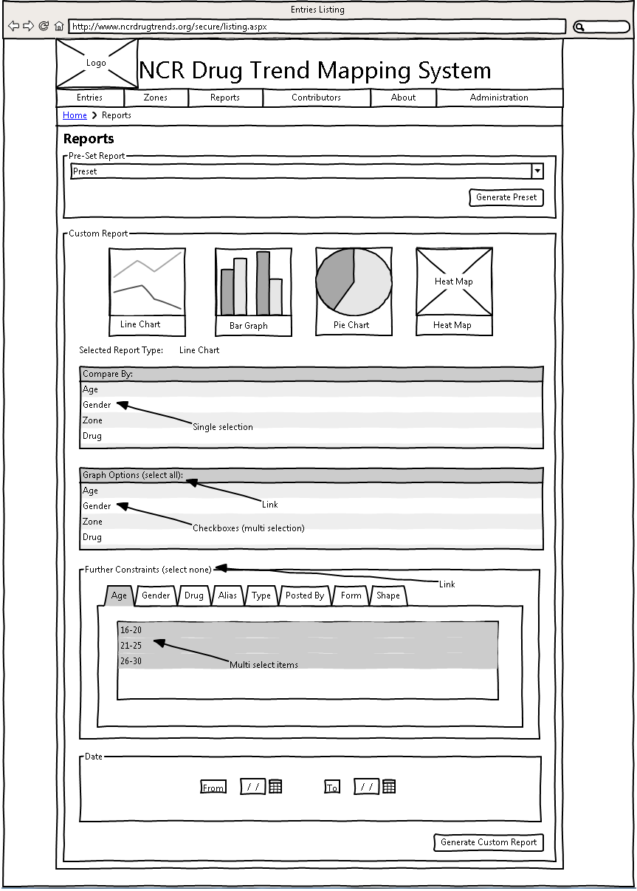

Figure 6: Report Page

## Contributors

### Main Contributors

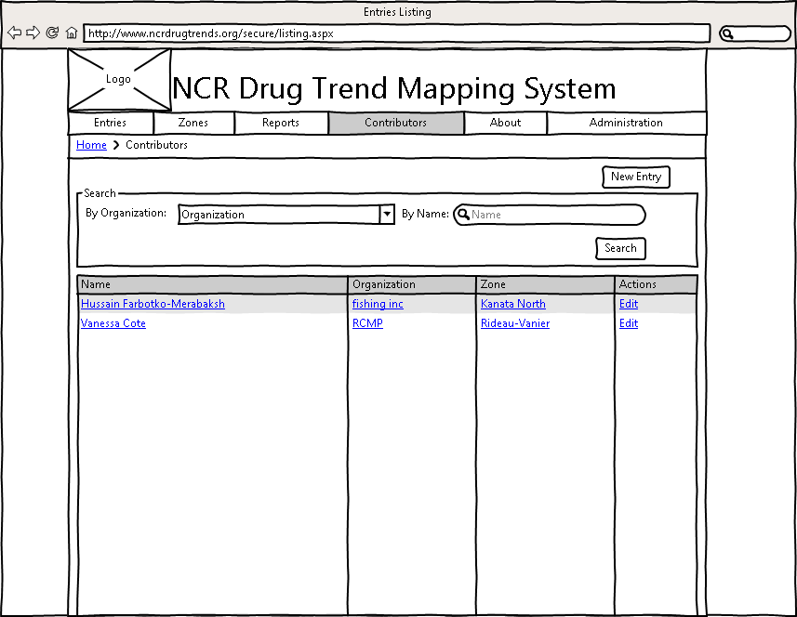

Figure 7: Contributors Page

1. Log into System.
2. Navigate to Contributors Page by selecting the Contributors Tab located in the navigation bar below the page Title.
3. The Table is populated upon page load, with the following row information: Name of Contributor, Contributor’s Organization, Contributor’s Zone and an Actions Column that contains a Link to edit the Contributor’s Information.
4. Clicking on a Contributor’s Name will redirect you to the selected Contributor’s Information Page. There you may view and if desired, make changes to contributor information.
5. Clicking on a Contributor’s Information will redirect to an Organization Page allowing the user to view only the selected Organization Information.
6. Clicking on a Contributor’s Zone will redirect to a Zone Page allowing the user to view only the selected Zone Information.
7. The Table has two search methods located above the Table: Search by Organization and Search by Contributor Name, which will filter the table contents to match the search specifications.
8. Lastly, a button to allow the user to create a New Entry has been created, located in the top right section of the page right below the Navigation Bar.

### Edit Contributor

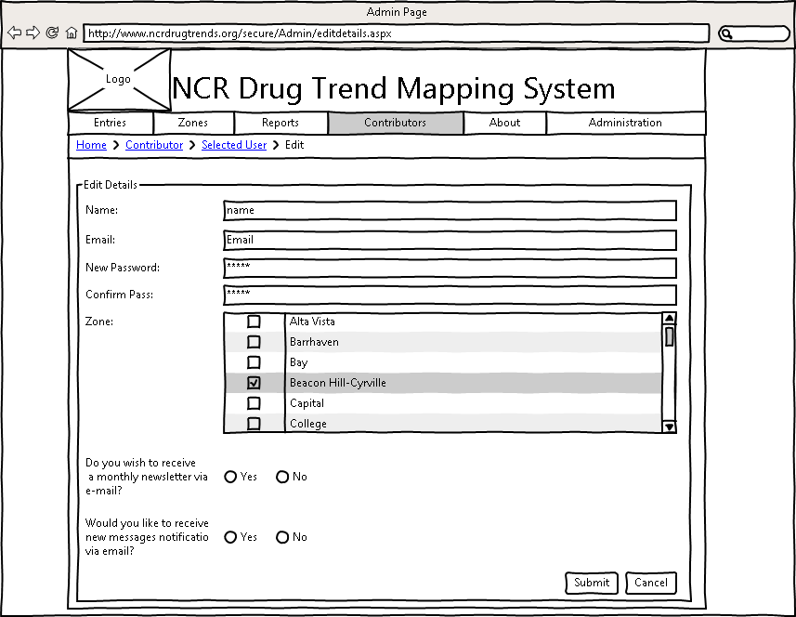

Figure 8: Edit Contributor

1. Log into System.
2. Navigate to Contributors Page by selecting the Contributors Tab located in the navigation bar below the page Title.
3. Visually choose a Contributor Name and click the Edit Link on the same line as the selected Contributor, which is located under the Actions Column in the table. This redirects you to the Edit Contributor Page. You may also access this Page via the method below.
4. Select a Contributor’s Name in order to investigate the Contributor’s information. Once at the next page, locate the Edit Button located at the bottom of the page. Click the Edit Button and arrive at the new page.
5. Once on the Contributor Edit Page, the user has the options to change: Name, Email, New Password, the Zone or Zones they would like to be associated with, whether the user would like to receive monthly newsletters or receive email notifications about received messages.
6. Submit to Save, Cancel to disregard changes.

## About

### Main About Screen

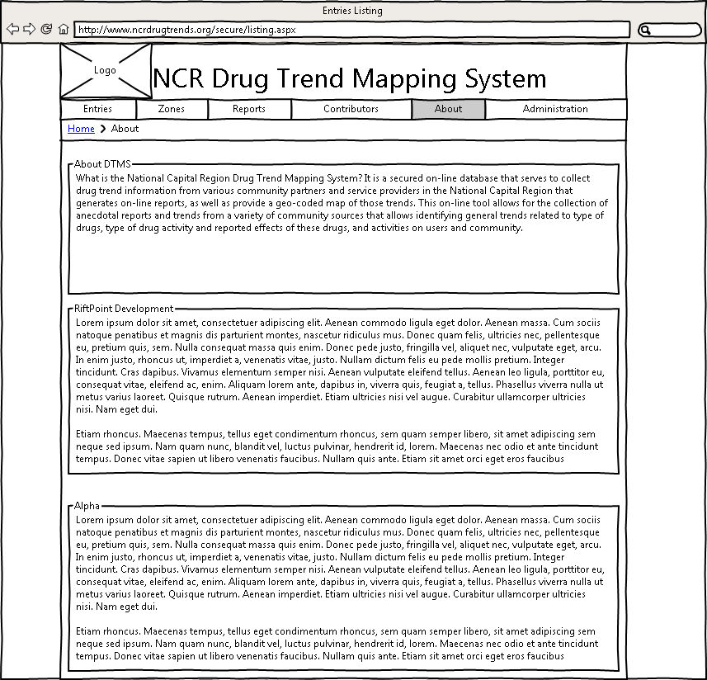

Figure 9: About

1. Log into the System
2. Navigate to the About page.
3. View the About page.

## Administration

### Accessing the main page

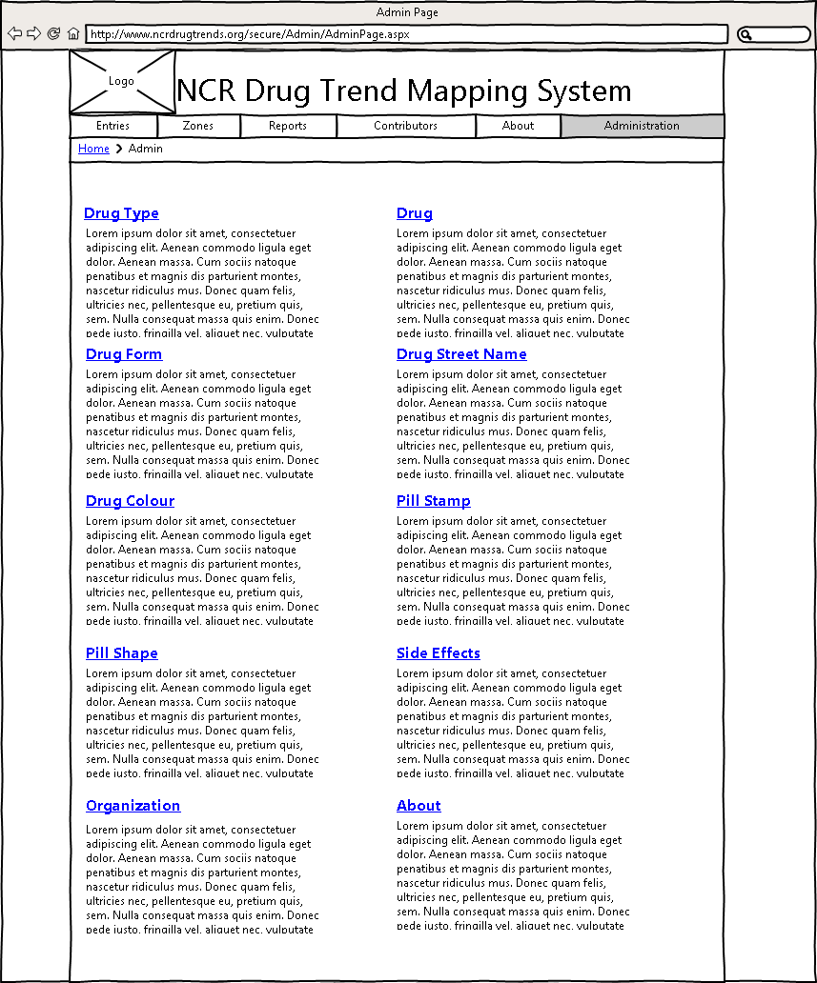

Figure 10: Admin

1. Login to the main site.
2. Click on the “Administrator” tab.
3. This will lead you to a list of the different types of Drug Details that can be submitted to the site.

### View summary information

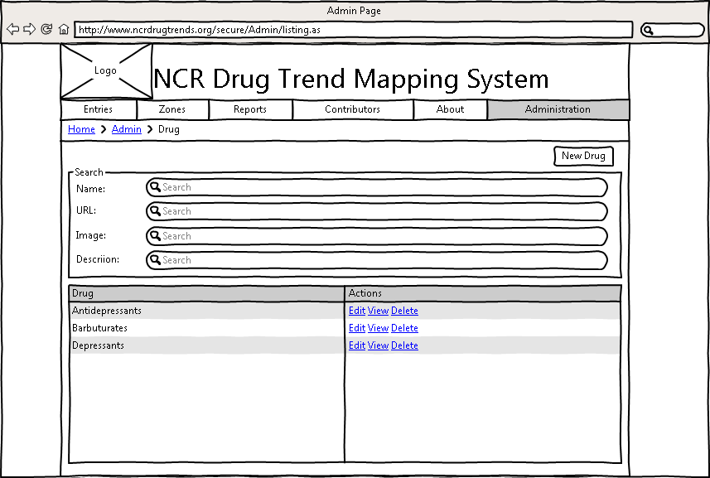

Figure 11: View Summary Information

1. Select the appropriate Detail to edit by clicking the link with the proper name.
2. This will lead you to a list of entries for the type you selected.
3. To filter out some of the entries, use the appropriate search filter.
4. To add a new entry of the current type, select the “New” button located above the search filters.
5. To edit the details of a Drug Detail, select the “Edit” link. To view the details of the value, select the “View” link. To remove an incorrect Drug Detail, select the “Delete” link.

### Adding a new Drug Detail

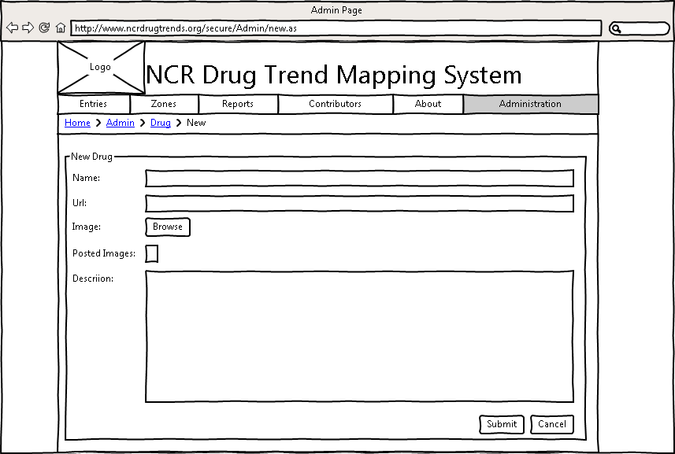

Figure 12: Drug Details

1. Select the “New” button.
2. This will lead you to a new form page where you can enter all of the details for the Drug Detail.
3. If the information is correct, select the “Submit” button to confirm the new detail. To return to the summary page without saving the detail, select the “Cancel” button.

NOTE: for Section 1.6.3, 1.6.4, 1.6.5 the following fields will be displayed:

|  |  |
| --- | --- |
| Page | Fields to Display |
| Drug Type | Name, Description |
| Drug | Name, Description, URL, Image |
| Drug Form | Name, Description |
| Drug Street Name | Name, Drug, Description |
| Drug Color | Name, Description |
| Pill Stamp | Name, Description |
| Pill Shape | Name, Description |
| Side Effect | Name, Description |
| Organization | Name, Website, Address, Description |
| About | Name, Description |

### Editing a Drug Detail

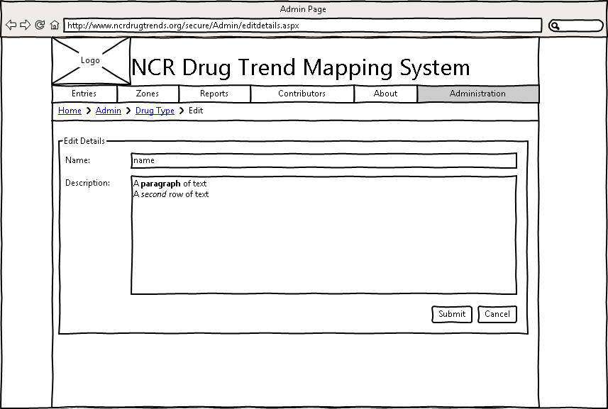

Figure 13: Edit Drug Details

1. Select the “Edit” link.
2. This will lead you to a form similar to the “New” form described above, but the fields will be filled with the details from the currently selected detail.
3. If you wish to keep the changes, select the “Submit” button to confirm. To return to the summary page without saving changes, select the “Cancel” button.

### View Drug Detail

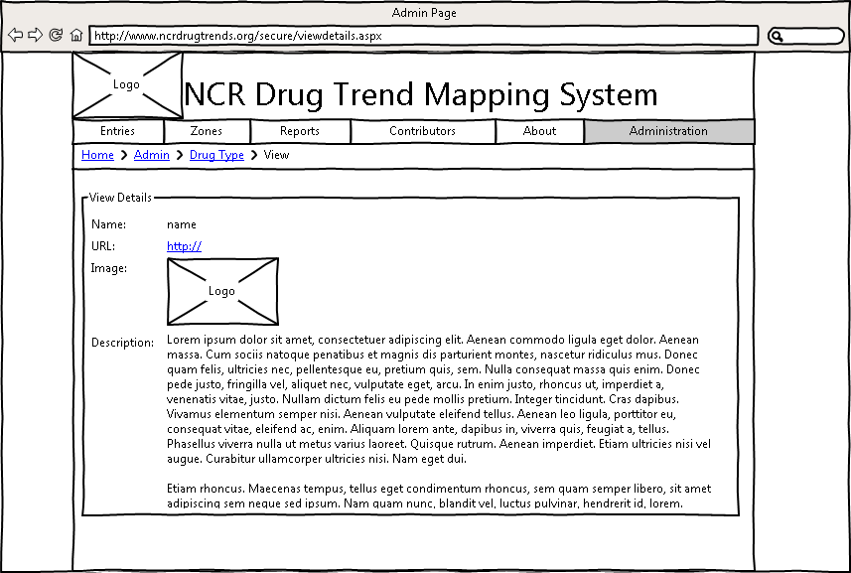

Figure 14: View Drug Details

1. Select the “View” link.
2. This will lead you to a page that displays all of the information on the Drug Detail.

### Delete Drug Detail

1. Select the “Delete” link.
2. There will be a prompt asking for confirmation for the deletion.
3. Select “Yes” to confirm, and continue on with the deletion. Select “No” to cancel the deletion.
4. The prompt will then disappear, and depending on your confirmation, the Drug Detail will be gone.

## Messages

### View Inbox

* + - 1. Log On to the System.
      2. Click on the “Go to Message Centre” link at the top right of the page.

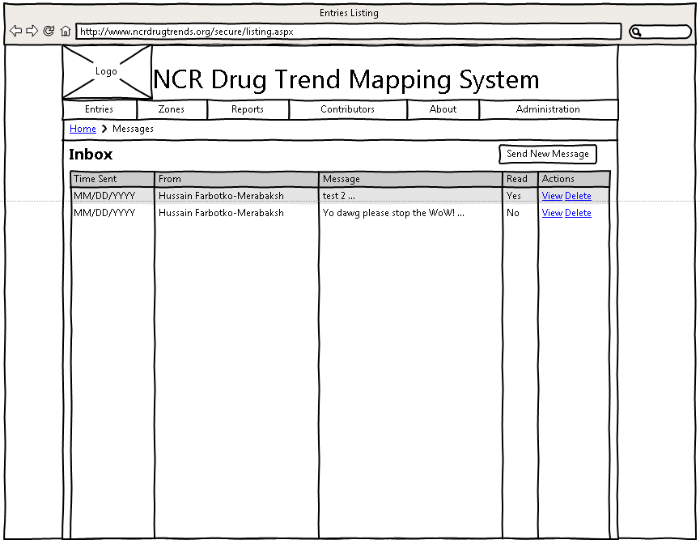

Figure 15: Message Centre

1. You will see a list of messages. Within this list you can click “View” to see the message in detail, or you can delete the message by clicking “Delete.”

### View a Message

* + - 1. From your inbox, click the “View” button on the message you want to read.
      2. Enjoy your message!

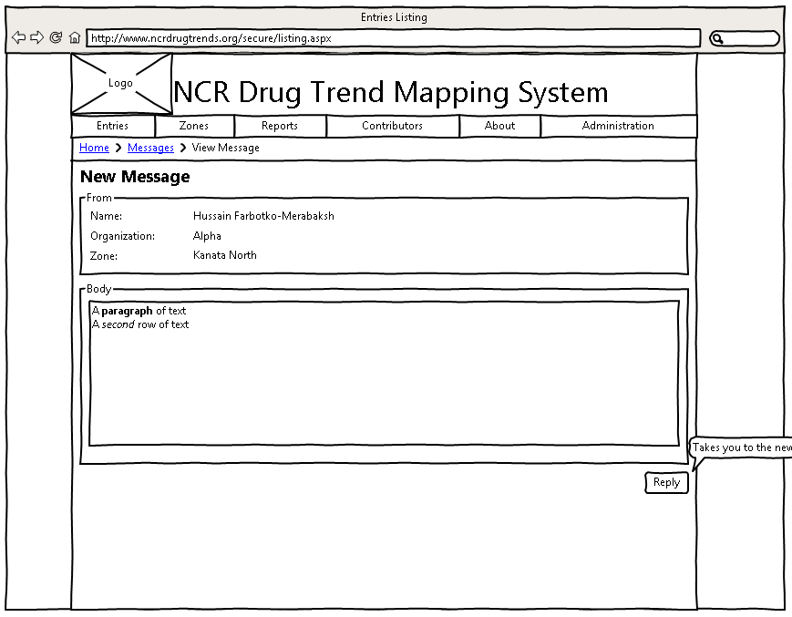

Figure 16: View Message

### Reply to a message

From the Message Centre, view the details of a particular message.

* + - 1. Click the “Reply” button.
      2. Enter your message and click “Send” to send the message.